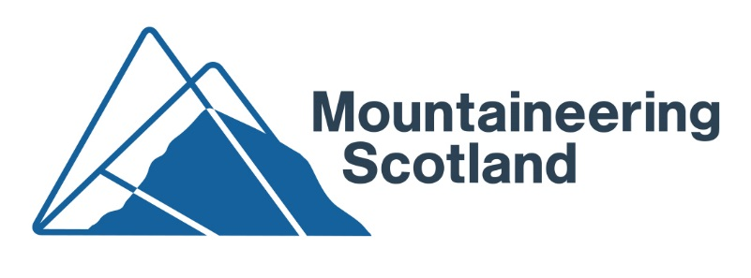
Press Release 20 March 2019 For immediate release

Hydro decision ‘disappointing’
Mountaineering Scotland questions quality of protection for special landscapes

Mountaineering Scotland has called on the Scottish Government to review a decision which will damage one of Scotland’s most iconic landscapes.
A special meeting of The Highland Council today approved three hydropower proposals which will impinge on wild land areas in Glen Etive, itself part of a National Scenic Area.
Stuart Younie, Chief Executive Officer of Mountaineering Scotland, said: “This is a disappointing decision by The Highland Council. It brings into question the purpose and value of allocating special designations which are intended to help protect our finest landscapes. We understand the arguments being made in support of the proposed developments but feel there was a wider point of principle at stake today. This was about the stewardship of a national asset and we hope this decision has not set a dangerous precedent which encourages more development applications in our wild land and national scenic areas. “
Mountaineering Scotland’s Access and Conservation Officer Davie Black said: “We are disappointed at this decision as there were serious issues raised about the impact of these developments on the landscape here, an area of great importance for outdoor recreation.
“What do we have to do to save our best landscapes from heavy engineering?
“We would call on the Scottish Government to review this decision and to look carefully at how we protect a place that is double locked by landscape protections, between being a Wild Land Area and a National Scenic Area. These are national assets, places of outstanding beauty. It should be in the national interest to look after these areas, and yet these heavy engineering projects are to be allowed to destroy the very qualities that make these steep slopes and deep glens so special.”
No less than seven applications had been submitted to build hydro schemes on both sides of Glen Etive – which is currently designated as a National Scenic Area and identified as having outstanding wild land qualities. Each of the schemes would involve new road construction, bridge-building, trench digging, cement-pouring and power cabling, for a relatively low power output.
Mountaineering Scotland agreed that four of the proposed hydropower schemes fitted in with the already developed forestry plantations, but objected to the three applications on the eastern side of the glen which would spread development up the slopes, damaging the wild qualities of the mountainsides.
Members of The Highland Council’s Planning Committee visited the glen for themselves before approving all seven applications at a meeting in February.
There was widespread outcry at the decision and independent Councillor Andrew Baxter gained sufficient support for a motion to call a special meeting of The Highland Council to review the decisions in respect of the three most contentious applications - Allt Ceitlein, Allt Mheuran and Allt Chaorainn.
Ends
Notes for editors:
Image: Glen Etive. Photo by Richard Cross
http://www.mountaineering.scot/assets/contentfiles/media-upload/P7980749.jpg

Further information contact:
Neil Reid, Communications Officer, on 01738 493941 or 07444545293 or neil@mountaineering.scot

About Mountaineering Scotland:
- Mountaineering Scotland is the only recognised representative organisation for hill walkers, climbers and ski-tourers who live in Scotland or who enjoy Scotland’s mountains.
- Mountaineering Scotland provides training and information to mountain users to promote safety, self-reliance and the enjoyment of our mountain environment.
- The Mountaineering Scotland is a membership organisation with over 14,000 members representing hill walkers, climbers and mountaineers, funded through a combination of membership subscriptions, non-governmental grants and investment from sportscotland, which supports public initiatives and services in mountain safety, mountain training and the development and promotion of mountaineering activities.
- Mountaineering Scotland also acts for 75,000 members of the BMC or British Mountaineering Council on matters related to Landscape and Access in Scotland.
- Mountaineering Scotland landscape and access work is supported financially by the Scottish Mountaineering Trust and the BMC
- Mountaineering Scotland has launched the ClimbScotland initiative to encourage young people to participate in climbing and support their progression. It offers a dedicated website and a development team, which will introduce young people to climbing at schools, climbing walls and via youth organisations with a range of activities and events, while developing kids clubs and providing specialist support to parents, volunteers and teachers.
- Mountaineering Scotland is the national governing body for sports climbing. It offers pathways to climbing coaching, organises and promotes a range of regional and national climbing competitions, and manages the Scottish climbing and bouldering teams. It contributes to the management of the GB teams with the ultimate aim of seeing a Scottish athlete achieve a podium position in the Olympic Games.
- The MCofS is a not for profit company limited by guarantee and incorporated in Scotland. Company number SC322717.
- Mountaineering Scotland, The Granary, West Mill Street, Perth PH1 5QP

